Que 1) Plot a histogram, 10, 13, 18, 22, 27, 32, 38, 40, 45, 51, 56, 57, 88, 90, 92, 94, 99

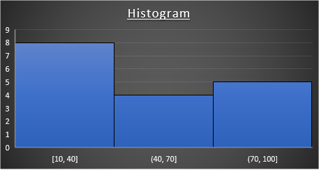

Que 2) In a quant test of the CAT Exam, the population standard deviation is known to be 100. A sample of 25 tests taken has a mean of 520. Construct an 80% CI about the mean.

Ans: σ= 100,  sample size (n)=25,  sample mean (*x̄*)=520, C.I. = 80%, α= 1-0.8=0.2

Since poplulation standard deviation is given we will use Z-test

Zvalue for 80% Confidence Interval is 1.28

0.1

0.8

0.1

-1.28 1.28

Margin of error = z value * σ/n^½ = 25.6

C.I. :- Point Estimator +_ Margin of error= *x̄* +_ 25.6

Upper bound= 545.6

Lower bound= 494.4

Confidence interval about Mean: We are 80% confident that the population mean score is between 494.4 to 545.6.

0.1

0.8

0.1

494.4 520 545.6

Que 3) A car company believes that the percentage of citizens in city ABC that owns a vehicle is 60% or less. A sales manager disagrees with this. He conducted a hypothesis testing surveying 250 residents & found that 170 residents responded yes to owning a vehicle.

1. State the null & alternate hypothesis.

**Null Hypothesis:** Citizens in city ABC owns a vehicle is 60% or less (p ≤ 0.6)

**Alternative Hypothesis:** Citizens in City ABC owns a a vehicle are more than 60% (p>0.6)

1. At a 10% significance level, is there enough evidence to support the idea that vehicle owner in ABC city is 60% or less.

**Ans:** α=10%=0.1, C.I. = 90%=0.9, n=250, x=170, sample proportion p̂= (170/250)=0.68

Po= 0.6, Qo= 0.4

One Tailed test:-

0.1

0.9

1.645

Zcalculated = p̂- Po/[(Po*Qo)/n]^½ = 2.58

Since Zc=2.58 > 1.645, we reject Null Hypothesis.

Inference: Citizens in City ABC owns a a vehicle are more than 60%.

Que 4) What is the value of the 99 percentile?

2,2,3,4,5,5,5,6,7,8,8,8,8,8,9,9,10,11,11,12

Ans: Vale for 99 percentile =(99/100) * (20+1) = 18.9 index position i.e **11.**

Que 5) In left & right-skewed data, what is the relationship between mean, median & mode?

Draw the graph to represent the same.

Ans: In Left Skewed data Mean<Median<Mode and in Right Skewed data Mean>Median>Mode.

